Woven Scarf

Materials: About 100g of any 3 or 4-ply soft yarn plus some interesting and fancy bits and pieces of textured yarns – in fact anything at all that takes your fancy.

Measurement: 109cm, 43inches long x 23cm, 9.25inches wide.

Machine: Standard gauge with ribber

No need for a tension swatch – use tension 7 throughout.

To knit: Using both beds and 3 or 4 ply yarn, cast on over 41-0-41 ns and arrange as shown in diagram below with 2 needles in WP, 6 ns in NWP, ending with 2ns in WP.

l l. . . . . . l l . . . . . . l l . . . . . . l l
l l. . . . . . l l . . . . . . l l . . . . . . l l

Tension 7, RC000. K360 rows. Transfer ribber stitches to main bed and cast off, working a chain of 6 sts in between each of the actual stitches to span the gap.

To complete: Using oddments of decorative yarns, weave several strands in and out of every 4 rows of knitting. Knot tassels to secure at each end and trim to approximately 10cm, 4inches.

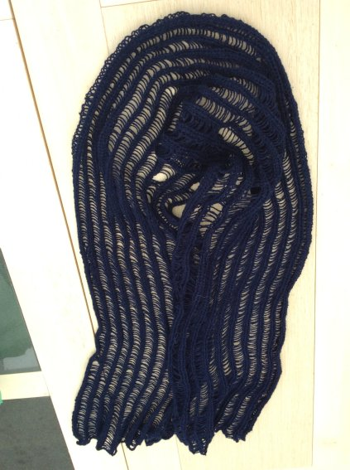 Plus: 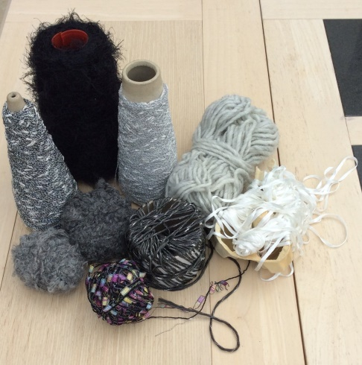

Equals: 