Baby Bootees

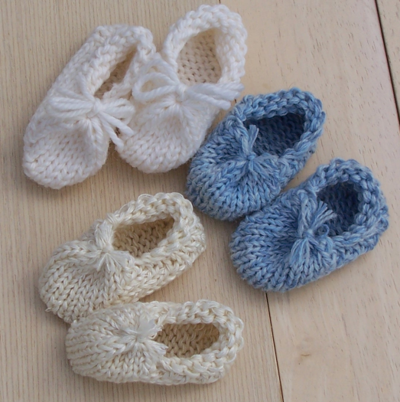

Best knitted on a chunky machine. Using several fine ends or perhaps two or three ends of double knit, or maybe a really chunky aran.

Tension – approximately 6 or appropriate to yarn

Make 2 the same:

RC 000. E-wrap cast on 14 needles. Knit 1 row. Add 3 weights carefully positioning them on the e-wrap row.

COL. Put carriage into hold position (HP).

*Put needle closest to carriage into HP. K1r. COR

Continue knitting bringing the needle closest to the carriage into HP each row until there are 4 sts left in WP. RC11.

On side nearest to carriage, pull back 1 needle into WP. K1r. Repeat until all needles are back in WP.* RC21

Repeat from * to *. RC41

Take off weights.

Bring up outside edge stitch from the first row of knitting and place it on the outside edge needles.

K1r. RC42

Cut yarn.

Take a fresh piece of yarn, thread on bodkin and double it. Thread this yarn through each stitch on the machine. Remove work from machine and gather the open stitches, tying a knot tightly. Double knot and leave short ends. Pull into the shape of a bootie.

